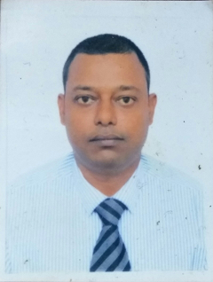
Prabir Kumar Parida

: Plot No. 16/2107/3289 Kapila Prasad, Bhubaneswar 751002, Odisha
 : +91-9937197578; : paridaprabirkumar@gmail.com
ADMINISTRATION, FACILITY & SALES FUNCTIONS PROFESSIONAL
Offering 19 + years of experience
PROFILE & STRENGTHS

- Competent, diligent & result oriented professional, offering exposure across General Administration, Facility & Transport functions, Sales & Marketing, Budgeting, Liasioning with internal and external bodies (Govt. and corporate ), finalizing the recruitment and training of manpower, Business Development, Inventory Management, Profit Centre Operations, Sales Promotion and Coordination; currently spearheading as Area Sales Manager ( Supply) with Oyo Hotels & Homes Pvt. Ltd. (OYO)

- Dexterity in formulating & implementing Marketing Planning & Business Development strategies and ensuring profitability of organization & employees. Diligent and resourceful professional with hands on expertise in devising measures for enhancing Operational Efficiency.
- Adept at monitoring Channel & Distribution Management; implementing effective Target Marketing & Penetration strategies to maximize sales and accomplishment of revenue and collection targets.
- Pivotal in setting up Promotional Campaigns while achieving Revenue, Profit and Business Growth Objectives while ensuring top line and bottom line profitability.
- Excellent time management skills with proven ability to work accurately and quickly prioritize, coordinate and consolidate tasks; resilient with a high level of personal integrity and energy experience.
- Demonstrated excellence in establishing a strong employer-employee bonding through personal touch & providing quality services
- Successfully led corporate policy implementation & facilities management across assignments.
- Managing activities pertaining to negotiating/ finalization of deals (commercial) with vendors & third part empanelment.
- Adept in handling day-to-day activities in coordination with internal / external departments for ensuring smooth business operation.
- Shortlist the team member for the training schedule required for his professional and organization growth.
- Assist in finalizing the Budget.

Core Competencies

⬥ Team Management  Business Development  General Administration  Transport Functions  Sales Promotion 
⬥ Channel & Distribution Management  Profit Centre Operations  Inventory Management  Sales & Marketing 
PROFESSIONAL EXPERIENCE

OYO HOTELS & HOMES PVT. LTD. – OYO ROOMS
ArEA Sales MANAGER(supply) FEB 2010 - till date
MM CEO – Channel Sales Odisha Dec 2018 - JAN 2020

- Developing a competitive business development and sales strategy, uncovering/creating new opportunities, identifying dynamic and flexible opportunities for market penetration and revenue generation.
- Responsible for meeting and greeting clients and visiting to various agencies and offices finalization of the distribution of promotional items; streamlining general administration of the organization including transport management and facility services.
- Training, mentoring, leading & monitoring the performance of team to ensure efficiency in operations and meeting of individual & group targets.
- Maintaining coordination and liaison with the various departments of the Government and other organizations such as AAI when required by the company; pivotal in handling purchase orders and raising purchase orders and invoice tracking.
- Efficiently handling and maintaining appropriate inventory & stock management practices and procedures, taking corrective measures wherever appropriate to execute effective inventory management.
- Interacting with client’s entities/businesses to understand their expansion plans and space requirements and providing strategic inputs for optimum space planning and avoiding ad hoc premises expansion.
- Implementing effective administrative policies and successfully coordinating administrative support for the office; conceptualizing and designing innovative strategies and ensuring smooth execution of overall tasks assigned by the management.
- Proficiently preparing effective standard operating procedure (SOP’s) to drive performance-improvement and for enhancing organizational results.

Interglobe Aviations Limited, Indigo Nov 2008-Nov 2018
Business Manager - Odisha

- Adroitly managed the sales and marketing operations, developed marketing strategies, studied the elements in a sales promotion plan & considered consumer preference and drive business volumes.
- Judiciously took proactive measures relating to factors impacting trade in order to grab the opportunities and provided valuable inputs for fine tuning the sales and the marketing strategies; involved in generating inquiries & target potential clients to build & maintain working relationship.
- Shouldered the responsibility of providing aid in business issues such as identifying growth opportunities, led generation while achieving business objectives, implementing policies and executing corporate strategies.

Sahara Airlines Limited & Jet Airways LIMITED INDIA Apr 2003-Nov 2008
Sales head
- Deployed the sales & marketing activity plan for front liners with target setting & reviewing measures; designed trade / secondary/retail schemes for the organization while conceptualized & implemented sales promotional activities via authorized dealers as a part of market development & branding effort.
- Designed and implemented the strategy that fulfill the objectives, maximizes revenues, profits and market share of the company while streamlining overall operations pertaining to product launch, business development and customer service.
- Formulated & implemented strategies/policies and reaching out to the unexplored market segments/customer groups for business expansion while gathering market intelligence, tracking competitors’ activities and providing valuable inputs.
Travels & Rentals Private Limited Mar 2001-Mar 2003
Executive Sales

RDM - Lufthansa Back Office Dec 2000-Mar 2001
Executive-Reservation

Genesis Travels Oct 2000-Dec 2000
Trainee
PROFESSIONAL & ACADEMIC CREDENTIALS

P.G.D.T.M
IITTM Bhubaneswar

Bachelor of Commerce (Accountancy Honors)
Utkal University

Key Trainings / Rewards
- Awarded as the best MM CEO for Q2 - 2019
- Attained the workshop on Advance sales and solutions in April 2018.
- Attained the workshop on e-mail etiquettes, negotiation skill and advance excel in March 2016.
- Attained the workshop (three phased programme) on enabling people to become managers started in March 2015.
- Attained the training for Presentation and sales etiquettes in Oct 2014.
- Attained training for improvisation of customer satisfaction, sales and solution in Sep 2014.
- Attained training for improvisation of customer satisfaction, sales and solution in Nov 2013.
- Attained training for the improvement on Sales & Marketing skill and customer satisfaction in Sept 2004.
- Attended training on development of sales skills and customer satisfaction in Aug 2003
- Attained the training for the development of sales skills in Oct 2001.

Specialization
Delivering lecture on “How to handle sales and customer effectively” arranged and invited by various management institutions.
Date of Birth: 15th July 1974
References: Available on request.

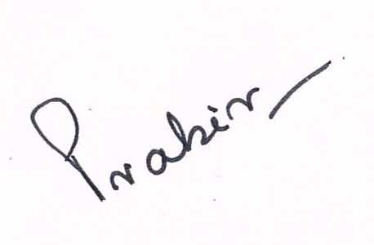
Date:  Place: Bhubaneswar |  | (Prabir Kumar Parida)

